Fraser- GitHub-Repository-Setup

Rep Link: <https://github.com/jfraser77/csd-340.git>

Local:

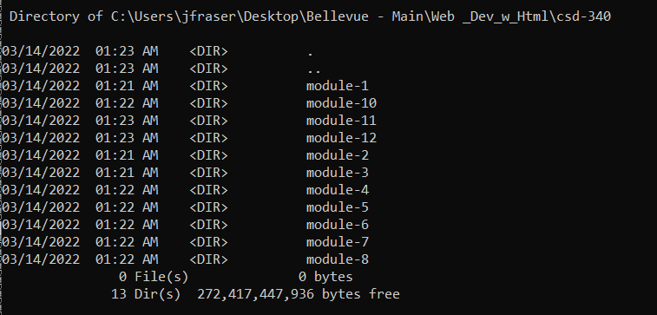

Git Repository:

